Team Name: YesWeDU

Team members: Du Lin, Michele De Donno, Riccardo Decarli, Giorgia Riparini, Filippo Notarnicola

Title: Du your espression

Genre: Puzzle Game

Platform: Pc/mobile

High concept and a biref overview of the game: Someone damned some works of art, and the subjects of this works take life. The player are a restorer and have to persuade the protagonists of the works of art to return in their original expressions.

Inspirational work of art that you used: The original work of art that we used for ispiration is the Morelli draw, then we look for other works with particularly expressions like court lady statue in Orient Art Museum in Turin or the portrait of Jusepe de Ribera.

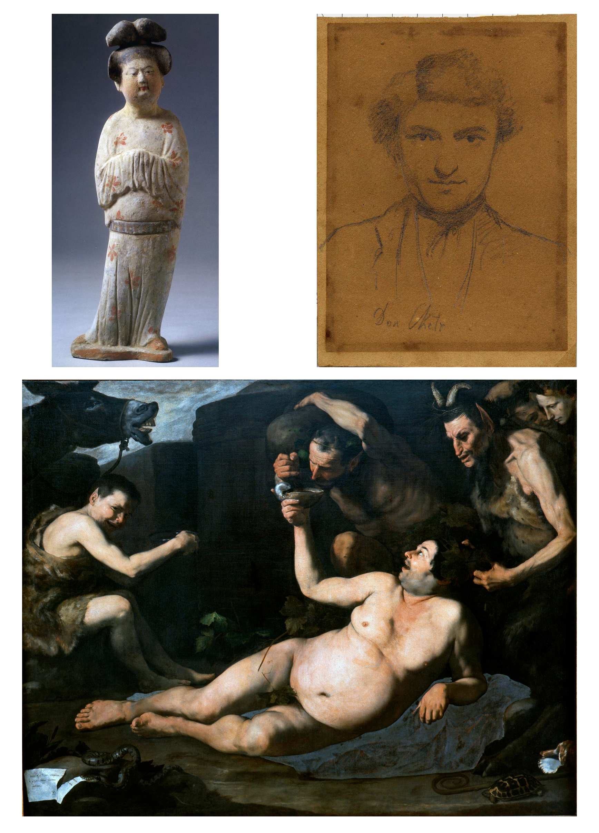

List of Gameplay mechanics: There is a limited number of questions to complete the goal. To make subjects to change expresions the player have to speak with him. If you say the wrong thing he change his expresion in the wrong way.

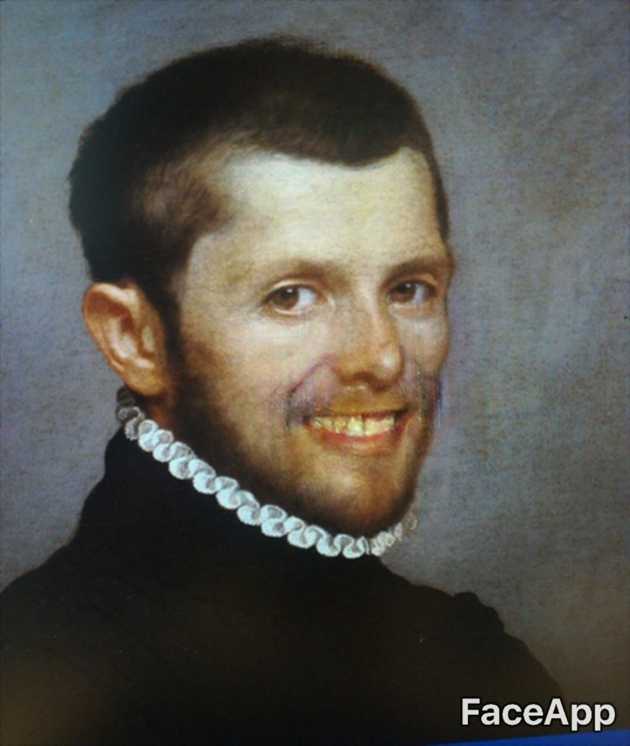

vv

